1. Selecione nome e dataNascimento dos alunos que começam com a letra "X".

[SELECT](http://localhost/phpmyadmin/url.php?url=https://dev.mysql.com/doc/refman/5.5/en/select.html) nome, dataNascimento FROM `aluno` WHERE nome [LIKE](http://localhost/phpmyadmin/url.php?url=https://dev.mysql.com/doc/refman/5.5/en/string-comparison-functions.html#operator_like) 'l%'

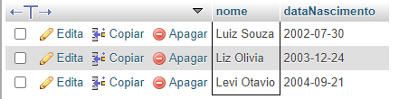

1. Selecione nome e telefone dos alunos que nasceram no mês x;

[SELECT](http://localhost/phpmyadmin/url.php?url=https://dev.mysql.com/doc/refman/5.5/en/select.html) nome, email, dataNascimento FROM `aluno` WHERE month(dataNascimento)='05'

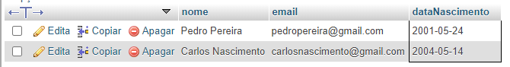

1. Selecione nome e telefone dos alunos que nasceram no ano x;

[SELECT](http://localhost/phpmyadmin/url.php?url=https://dev.mysql.com/doc/refman/5.5/en/select.html) nome, email, dataNascimento FROM `aluno` WHERE [year](http://localhost/phpmyadmin/url.php?url=https://dev.mysql.com/doc/refman/5.5/en/date-and-time-types.html)(dataNascimento)='2004'

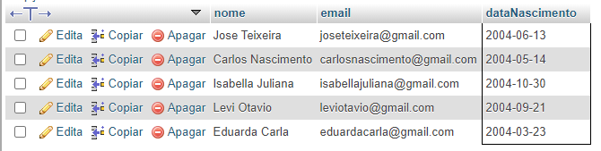

1. Ordene os alunos em ordem decrescente por Turma;

[SELECT](http://localhost/phpmyadmin/url.php?url=https://dev.mysql.com/doc/refman/5.5/en/select.html) \* FROM `aluno` ORDER by turma desc

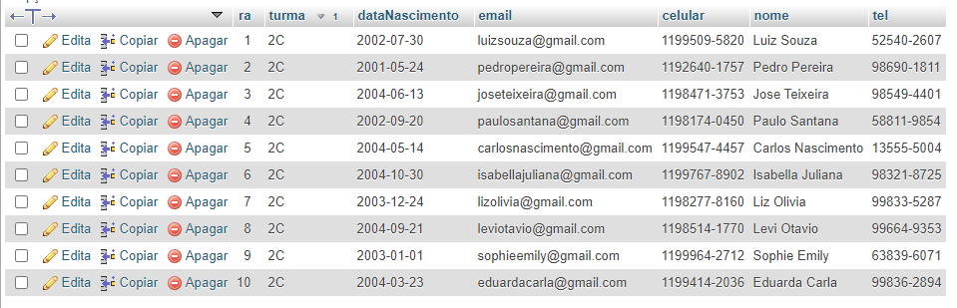

1. Selecione os livros do Gênero "X";

[SELECT](http://localhost/phpmyadmin/url.php?url=https://dev.mysql.com/doc/refman/5.5/en/select.html) titulo, autor, genero FROM `livros` WHERE genero [like](http://localhost/phpmyadmin/url.php?url=https://dev.mysql.com/doc/refman/5.5/en/string-comparison-functions.html#operator_like) '%Ficcao%'

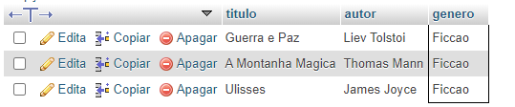

1. Quantos livros tem cadastrados;

[SELECT](http://localhost/phpmyadmin/url.php?url=https://dev.mysql.com/doc/refman/5.5/en/select.html) [count](http://localhost/phpmyadmin/url.php?url=https://dev.mysql.com/doc/refman/5.5/en/group-by-functions.html" \l "function_count" \t "mysql_doc)(\*) FROM `livros`



1. Selecione os livros do autor "X";

[SELECT](http://localhost/phpmyadmin/url.php?url=https://dev.mysql.com/doc/refman/5.5/en/select.html) titulo, autor, genero FROM `livros` WHERE autor='James Joyce'



1. Selecione os empréstimos que aconteceram no mes "X";

[SELECT](http://localhost/phpmyadmin/url.php?url=https://dev.mysql.com/doc/refman/5.5/en/select.html) data\_emprestimo, data\_devolucao FROM `emprestimo\_devolucao` WHERE data\_emprestimo BETWEEN '2019-01-01' [and](http://localhost/phpmyadmin/url.php?url=https://dev.mysql.com/doc/refman/5.5/en/logical-operators.html#operator_and) '2019-01-31'

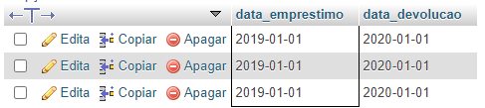

1. Selecione os empréstimos que aconteceram entre os anos "X" e "Y";

[SELECT](http://localhost/phpmyadmin/url.php?url=https://dev.mysql.com/doc/refman/5.5/en/select.html) data\_emprestimo, data\_devolucao FROM `emprestimo\_devolucao` WHERE data\_emprestimo BETWEEN '2019-01-01' [and](http://localhost/phpmyadmin/url.php?url=https://dev.mysql.com/doc/refman/5.5/en/logical-operators.html#operator_and) '2020-12-31'

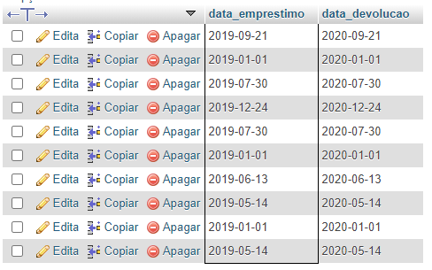

1. Selecione os bibliotecários que são da cidade "X";

[SELECT](http://localhost/phpmyadmin/url.php?url=https://dev.mysql.com/doc/refman/5.5/en/select.html) nome, cidade FROM `bibliotecario` WHERE cidade='Ribeirão Pires'



1. Ordene os bibliotecários em ordem alfabética;

[SELECT](http://localhost/phpmyadmin/url.php?url=https://dev.mysql.com/doc/refman/5.5/en/select.html) \* FROM `bibliotecario` ORDER by nome



1. Ordene os livros por gênero;

[SELECT](http://localhost/phpmyadmin/url.php?url=https://dev.mysql.com/doc/refman/5.5/en/select.html) \* FROM `livros` ORDER by genero

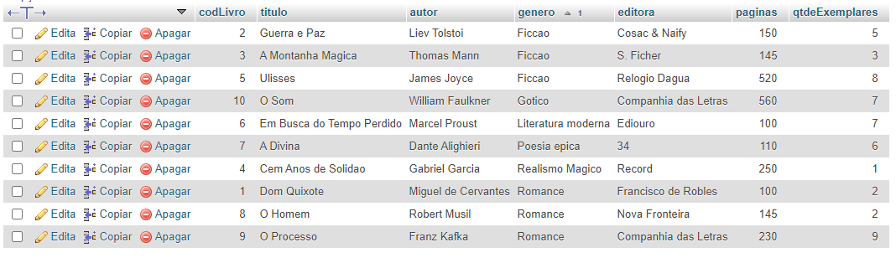

1. Selecione os livros da editora "X";

[SELECT](http://localhost/phpmyadmin/url.php?url=https://dev.mysql.com/doc/refman/5.5/en/select.html) titulo, autor, genero, editora FROM `livros` WHERE editora='Companhia das Letras'

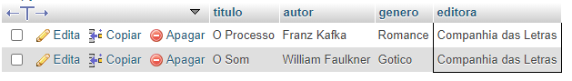

1. Selecione os livros dos autores "X" ou genero "Y" e que tenham menos de

"Z" páginas;

[SELECT](http://localhost/phpmyadmin/url.php?url=https://dev.mysql.com/doc/refman/5.5/en/select.html) titulo,autor,genero,paginas FROM `livros` WHERE (autor='Miguel de Cervantes' [or](http://localhost/phpmyadmin/url.php?url=https://dev.mysql.com/doc/refman/5.5/en/logical-operators.html" \l "operator_or" \t "mysql_doc) genero [like](http://localhost/phpmyadmin/url.php?url=https://dev.mysql.com/doc/refman/5.5/en/string-comparison-functions.html#operator_like) '%Romance%') [and](http://localhost/phpmyadmin/url.php?url=https://dev.mysql.com/doc/refman/5.5/en/logical-operators.html" \l "operator_and" \t "mysql_doc) paginas<500

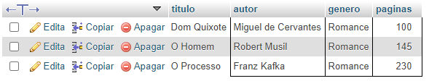

1. Selecione os livros com titulo que começam com a letra "X" e genero "X";

[SELECT](http://localhost/phpmyadmin/url.php?url=https://dev.mysql.com/doc/refman/5.5/en/select.html) titulo,autor,genero FROM `livros` WHERE titulo [like](http://localhost/phpmyadmin/url.php?url=https://dev.mysql.com/doc/refman/5.5/en/string-comparison-functions.html#operator_like) 'o%' [and](http://localhost/phpmyadmin/url.php?url=https://dev.mysql.com/doc/refman/5.5/en/logical-operators.html#operator_and) genero [like](http://localhost/phpmyadmin/url.php?url=https://dev.mysql.com/doc/refman/5.5/en/string-comparison-functions.html#operator_like) '%Romance%'

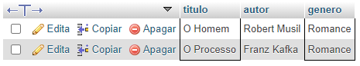

1. faça a média de paginas de todos os livros;

[SELECT](http://localhost/phpmyadmin/url.php?url=https://dev.mysql.com/doc/refman/5.5/en/select.html) [AVG](http://localhost/phpmyadmin/url.php?url=https://dev.mysql.com/doc/refman/5.5/en/group-by-functions.html#function_avg)(paginas) from livros



1. faça a soma de páginas de todos os livros;

[SELECT](http://localhost/phpmyadmin/url.php?url=https://dev.mysql.com/doc/refman/5.5/en/select.html) [sum](http://localhost/phpmyadmin/url.php?url=https://dev.mysql.com/doc/refman/5.5/en/group-by-functions.html#function_sum)(paginas) from livros



1. Selecione os livros que tenham entre 4 e 6 exemplares

[SELECT](http://localhost/phpmyadmin/url.php?url=https://dev.mysql.com/doc/refman/5.5/en/select.html) autor, titulo, genero, qtdeExemplares FROM `livros` WHERE qtdeExemplares BETWEEN 4 [and](http://localhost/phpmyadmin/url.php?url=https://dev.mysql.com/doc/refman/5.5/en/logical-operators.html#operator_and) 6

